

**ICT Core Content Notes - Month 4 @arjoio**

**D** Interest Rate Effects On Currency Trades

**f)** Reinforcing Liquidity Concepts & Price Delivery

**El** Orderblocks

**El** Mitigation Blocks **El** ICT Breaker Block **El** ICT Rejection Block

**El** Reclaimed ICT Orderblock

**El** ICT Propulsion Block

**EJ** ICT Vacuum Block

**B** Liquidity Pools

**e** Liquidity Voids

**m** ICT Fair Value Gaps FVG

**6** Divergence Phantoms

**a** Double Bottom Double Top "' ***PDF notes***

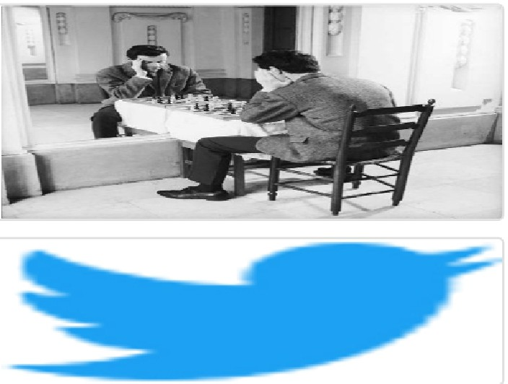Arjo I Twitter, lnstagram I Linktree

Linktree. Make your link do more.

, https://t.co/HhmmTN1fUI

JavaScript is not available.

https:/ltwitter.com/arjoio